Accessing the BASA website

There are no limits to the number of individual subscribers for each BASA member company and we actively encourage each BASA member company to make sure that they encourage employees to subscribe and have access to the technical and business information that is posted regularly.

Each member company has a nominated data controller (or controllers) on the website, so it is important that these data controller contacts are kept current. New subscribers are required to self-register and the data controller and BASA secretary will receive an email notification when this occurs, requesting that the subscription is approved. Either the member company data controller or the BASA secretary can approve website access.

How to get access to the BASA website
- Go to https://www.basa.uk.com/Account/Login and using the option on the right Register by Applying to an existing company. Current BASA member companies are accessed by selecting using the up/down arrows
- Using the up/down arrows select your company from the options.
- Click ‘Subscribe’
- In the next screen enter your details
- When you enter your email address, if you are already registered for the BASA website, then you will see the following error message:

- You then have 2 choices. Either go back to the login screen https://www.basa.uk.com/Account/Login and click on Forgot Password (in orange and under the orange Log In box)
- Or email me (secretary@basa.uk.com) and I will send you a temporary password to access your current subscription.
- A number of members are having difficulty receiving the reset email (check spam filters), so you may prefer to email me rather than using the forgot password link.
- Once you have received a temporary email from me, then log on and click on Manage account on the top right

- You can then choose a suitable password for future access

- Once you have access, you can click on the green ‘Become Data Controller’ button if you wish to change your company details. The current data controller is listed in your member profile, with all the registered website subscribers.

- Please choose the correct communication preferences, by clicking on the Membership profile option in the top left of the screen, and the selecting the option to receive weekly working group and/or general content notifications from the next screen.
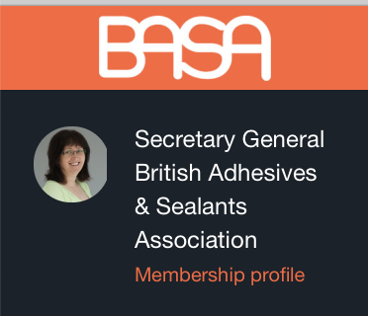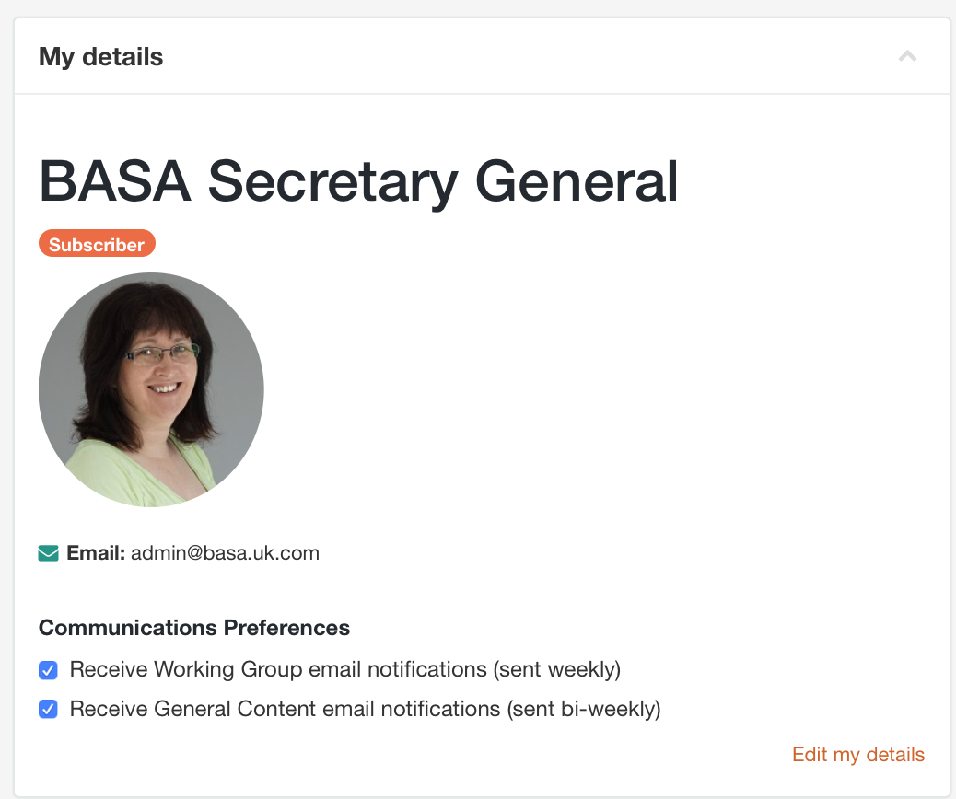

If you have any problems with the process, please email me.

Lorna Williams
BASA Secretary
24 Laurel Close, Mepal. Ely, Cambridgeshire, CB6 2BN
VAT Number 382748811
Tel: +44 330 22 33 290
Mob: +44 7480 558814
Fax: +44 330 22 33 408

Email: secretary@basa.uk.com
Website: www.basa.uk.com
Event Bookings: www.basaevents.co.uk
For information Williams Consultancy Professionals is the contracting party with BASA for the Secretarial responsibilities, with Lorna Williams as the representative of Williams Consultancy Professionals, and Rebecca Williams as Adminstrative Assistant for work under the BASA contract.

